Assignment – 1
Section 1: Multiple Choice

1. Which is following is NOT a component of the CPU?
1. ALU
2. RAM
3. CU
4. 1 and 3 both
- Ans. 2. RAM

2. What is the function of RAM in a computer?
Ans.
The function of RAM (Random Access Memory) in a computer is to temporarily store data and instructions that the CPU (Central Processing Unit) needs while performing tasks. RAM is volatile
memory, which means it loses all stored data when the computer is turned off.

3. Which of the following is a primary storage device?
1. HDD
2. SSD
3. SD card
4. 1 and 2 both
- Ans. 4. 1 and 2 both

4. What is the purpose of a GPU?
Ans.
The purpose of a GPU (Graphics Processing Unit) is to handle and accelerate the processing of visual data essentially, it is specialized hardware for rendering images, videos, and animations, as well as performing certain calculations much faster than a CPU for specific tasks.

Section 2: True or False

5. The motherboard is the main circuit board of a computer where other components are attached.
Ans. True

6. A UPS (Uninterruptible Power Supply) is a hardware device that provides emergency power to a load when the input power source fails.
Ans. True

7. An expansion card is a circuit board that enhances the functionality of a component.
Ans. True

Section 3: Short Answer

8. Explain the difference b/w HDD and SSD.
Ans.

Difference | SSD | HDD
Speed | Faster read/write speeds | Slower read/write speeds
Capacity and Associated Costs | Smaller capacity, higher cost per GB | Larger capacity, lower cost per GB
Operational Reliability | No moving parts, less prone to physical damage | Moving parts, more susceptible to shock
Power Consumption and Battery Life | Consumes less power, extends battery life | Consumes more power, can reduce battery life
Additional Storage | Can be more expensive for upgrades | Cheaper upgrades and additional storage
Nature of Operation | No mechanical movement | Mechanical movement
Operational Efficiency | Better performance under multitasking | May slow down under heavy multi-tasking

9. Describe the function of BIOS in a computer system.
Ans.
The BIOS (Basic Input/Output System) is low-level firmware that helps a computer start up and get ready to run an operating system. Its main functions are:
- Power-On Self-Test (POST)
When you turn on the computer, the BIOS checks that essential hardware—like the CPU, RAM, keyboard, and storage devices—is working properly.
- Hardware Initialization
It initializes and configures hardware components so they can communicate with the system (for example, setting up memory and detecting connected drives).
- Bootstrapping the Operating System
After POST, the BIOS looks for a bootable device (such as a hard drive, SSD, or USB) and loads the bootloader, which then starts the operating system.
- Providing Basic System Services
BIOS offers basic input/output routines that the operating system or bootloader can use to interact with hardware, especially during early startup.
- System Configuration
Through the BIOS setup utility, users can change system settings like boot order, system time, and hardware parameters.

10. List and briefly explain three input devices commonly used with computers.
Ans.
- Keyboard
Used to enter text, numbers, and commands into the computer.
- Mouse
Allows users to point, click, drag, and interact with items on the screen.
- Scanner
Converts physical documents or images into digital form for use on a computer.

Section 4: Practical Application

11. Identify and label the following components on a diagram of a motherboard:
- CPU
- RAM slots
- SATA connectors
- PCI-E slot

Ans.
- CPU
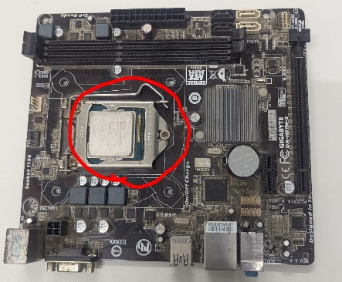

- RAM slots
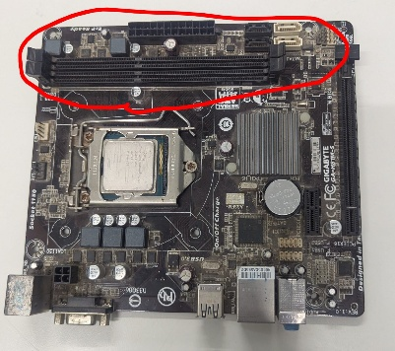

- SATA connectors
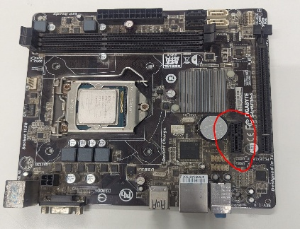

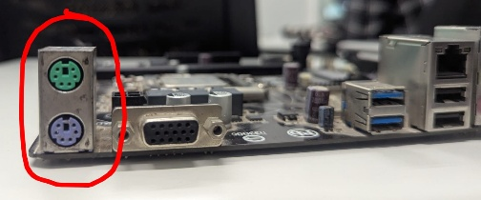
- PCI-E slot

12. Demonstrate how to install a RAM module into a computer.
Ans.
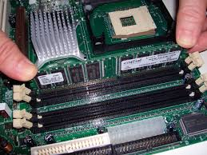

- Turn off the computer and unplug it.
- Open the computer case.
- Touch metal on the case to ground yourself.
- Locate the RAM slots on the motherboard.
- Open the clips on the RAM slot.
- Align the notch on the RAM with the slot.
- Press the RAM firmly until the clips click closed.
- Close the case, plug in, and power on.

Section 5: Essay

13. Discuss the importance of proper cooling mechanisms in a computer system. Include examples of cooling methods and their effectiveness.
Ans.
Proper cooling is critical to a computer system because it keeps components operating within safe temperature limits, ensuring performance, stability, and long-term reliability.

When a computer runs, parts like the CPU, GPU, and power supply generate heat. If this heat isn’t removed effectively, components can overheat, leading to thermal throttling (automatic performance slowdown), system crashes, data loss, or even permanent hardware damage. Good cooling also extends component lifespan and keeps the system quieter and more energy-efficient.

Common cooling methods and their effectiveness
1. Air cooling
This is the most common method and uses heat sinks and fans to move heat away from components.
- Examples: CPU fan and heat sink, case fans
- Effectiveness: Very effective for most everyday and gaming systems, affordable, reliable, and easy to maintain.
2. Liquid cooling
Uses liquid (usually water) to absorb heat and move it to a radiator where fans dissipate it.
- Examples: All-in-one (AIO) liquid coolers, custom water-cooling loops
- Effectiveness: Highly effective for high-performance CPUs and GPUs, better at handling heavy workloads, but more expensive and complex.
3. Passive cooling
Relies on heat sinks without fans, using natural airflow.
- Examples: Fanless CPUs, heat sinks in small or silent PCs
- Effectiveness: Very quiet and low maintenance, but only suitable for low-power systems.
4. Thermal interface materials (thermal paste/pads)
Placed between the processor and heat sink to improve heat transfer.
- Effectiveness: Essential for efficient cooling; poor or dried-out thermal paste can significantly increase temperatures.
5. Proper case airflow design
Uses intake and exhaust fans to move cool air in and hot air out.
- Effectiveness: Crucial for overall system cooling; good airflow improves the performance of all other cooling methods.

Conclusion
Proper cooling mechanisms prevent overheating, maintain consistent performance, reduce hardware failure, and extend the lifespan of a computer system. Choosing the right cooling method depends on system usage, performance needs, budget, and noise preferences, but some form of effective cooling is essential for every computer.

14. Explain the concept of bus width and its significance in computer architecture.
Ans.
Bus width refers to the number of bits a computer bus can transmit simultaneously between components such as the CPU, memory, and input/output devices.

What bus width means
- It is measured in bits (e.g., 8-bit, 16-bit, 32-bit, 64-bit).
- A wider bus can carry more data at the same time.
- For example, a 64-bit data bus can transfer twice as much data per cycle as a 32-bit data bus.

Types of bus width
- Data bus width: Determines how much data can be transferred at once.
- Address bus width: Determines how much memory the system can address (access).
- Example: A 32-bit address bus can address up to 4 GB of memory.
- Control bus width: Carries control signals (not usually measured the same way but still important).

Significance in computer architecture
- Performance: Wider bus widths increase data transfer rates, improving overall system speed.
- Memory capacity: Address bus width limits the maximum amount of RAM the system can use.
- Efficiency: More data moved per cycle means fewer cycles are needed for tasks.
- Compatibility: Bus width affects processor design, operating system support, and hardware compatibility.

Example
- A 32-bit system processes 32 bits of data at a time and has limited memory addressing.
- A 64-bit system processes more data per cycle and can support much larger amounts of RAM, making it better for modern applications.

Conclusion
Bus width is a key factor in determining a computer’s data handling capability, memory capacity, and performance. Wider buses enable faster and more efficient communication between system components, making them essential in modern computer architecture.

